**Common image defogging algorithms**

***Principle of histogram equalization algorithm***

Image histogram represents the probability of each gray level in the image. If an image has N pixels, rk represents the gray level corresponding to the k-th gray level, L represents the number of gray levels, and nk represents the number of pixels of gray level rk, then the histogram can be defined as:



Histogram equalization is to change the histogram distribution of the image into an approximately uniform distribution, so as to enhance the contrast of the image. It is divided into two categories: global histogram equalization and local histogram equalization. The former is to equalize the histogram of the whole image, while the latter is processed by dividing multiple sub blocks. The processing steps of histogram equalization are as follows:

1. Scan each pixel of the original gray image in turn to calculate the gray histogram of the image.
2. Calculate the cumulative distribution function of gray histogram.
3. According to the principle of cumulative distribution function and histogram equalization, the mapping relationship between input and output is obtained.
4. Finally, the image is transformed according to the mapping relationship.

***Principle of Multi-scale Retinex (MSR) algorithm***

Retinex theory, the most widely used a priori constraint in the solution of eigen image decomposition problem, is that it is a composite word composed of English words retina and cortex. The theory focuses on explaining the perception model of color and brightness of the human visual system. The imaging process can be expressed as:



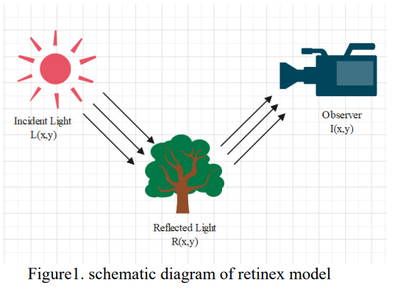

Where I(x, y) represents the original image, R(x,y) represents the reflected image, and l(x, y) represents the incident illumination image. Perform logarithmic operation on equation (2), then:



Single scale Retinex constructs a Gaussian surround function, then filters the RGB three channels of the image respectively, and then subtracts the original image and the illumination component in the logarithmic domain to obtain the reflection component, which is used as the output image. The algorithm can enhance the details of the image. Expressed as follows:



Where,i represents the category of color channel (RGB), and Represents Gaussian surround function. However, because the algorithm is difficult to maintain color fidelity[8], we use Multi-Scale Retinex(MSR).This algorithm performs Gaussian filtering on different scales and then weighted average.The formula is as follows:



Among them,ωk represents the weight coefficient, and Fk(x,y) represents the weight ωk corresponds to the Gaussian surround function, and N represents the number of scales.

**optical transmission model**

In computer vision, the atmospheric scattering model is shown in Figure 2, which can be expressed as:

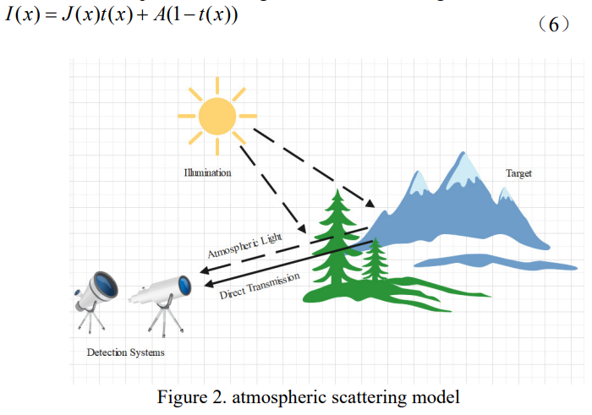

Where I(x) refers to the observed brightness, that is, the brightness obtained from the captured picture, which is a known value. J(x) is the image after defogging and restoration, that is, our goal. t(x) is the scene transmittance. A represents the global atmospheric light component. Therefore, we must reconstruct the original image by estimating atmospheric light a and scene transmittance t(x).

**Dark channel a priori**

After a large number of fog free outdoor images are counted, the a priori knowledge of dark channel is introduced. Some areas always exist in images with very low intensity in at least one color(RGB)channel, which can be described as follows:



